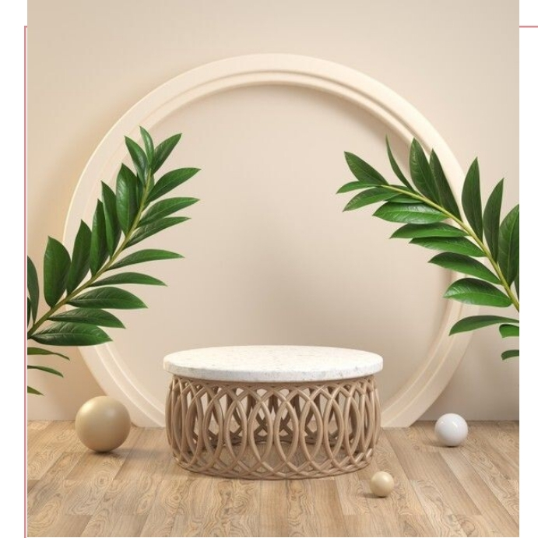
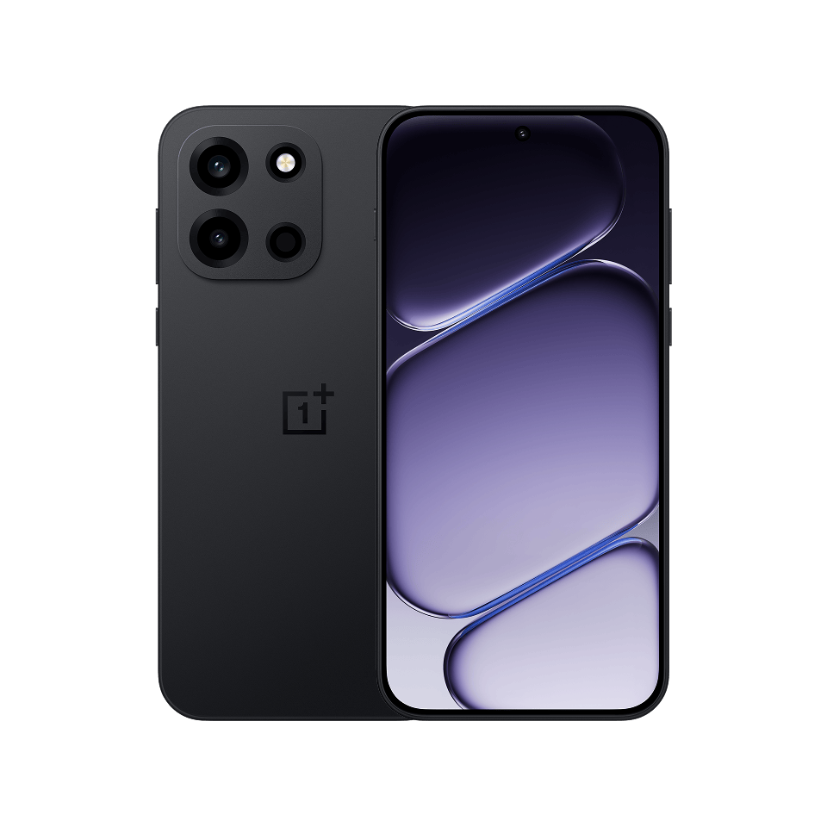














MASSIVE 8000mAh
80W supervooc fast charging
Very smooth scrolling and gaming experience
Premium design
ONE PLUS NOTOCHORD 6

